

**Journal Section** (Neurobiology of Diseases)

**Manuscript Type** (Original Article)

**Tumor spheroids of an aggressive form of central neurocytoma have transit-amplifying progenitor characteristics with enhanced EGFR and tumor stem cell signaling.**

Hye Young, Shin1, Kyung-Seok Han2†, Hyung Woo Park1†, Yun Hwa Hong3†, Yona Kim1†, Hyo Eun Moon1, Kwang Woo Park1, Hye Ran Park1, C. Justin Lee2, Kiyoung Lee1, Sang Jeong Kim3, Man Seung Heo4, Sung-Hye Park7, Dong Gyu Kim1, Sun Ha Paek1,5,6*

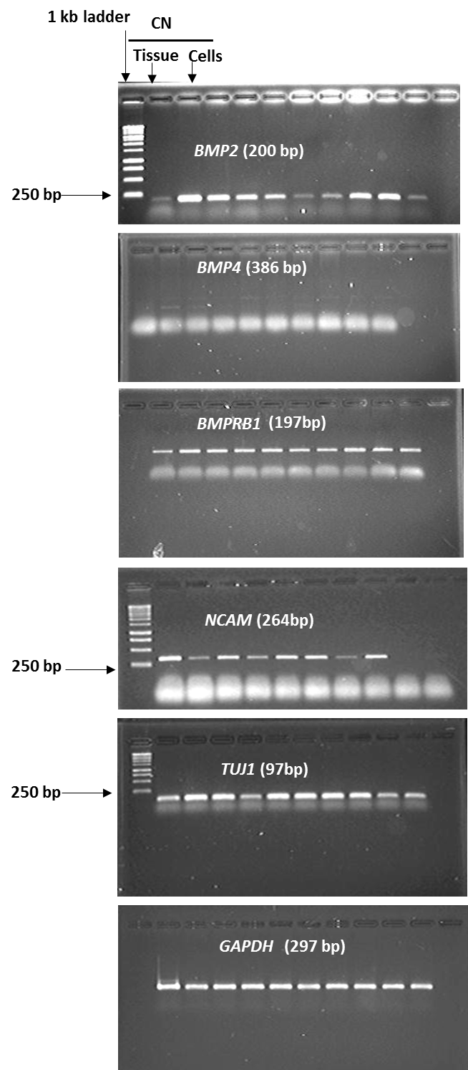**Supporting Information, full-length gel images of RT-PCR.**

**Fig. 1g**

**Fig. 1j**

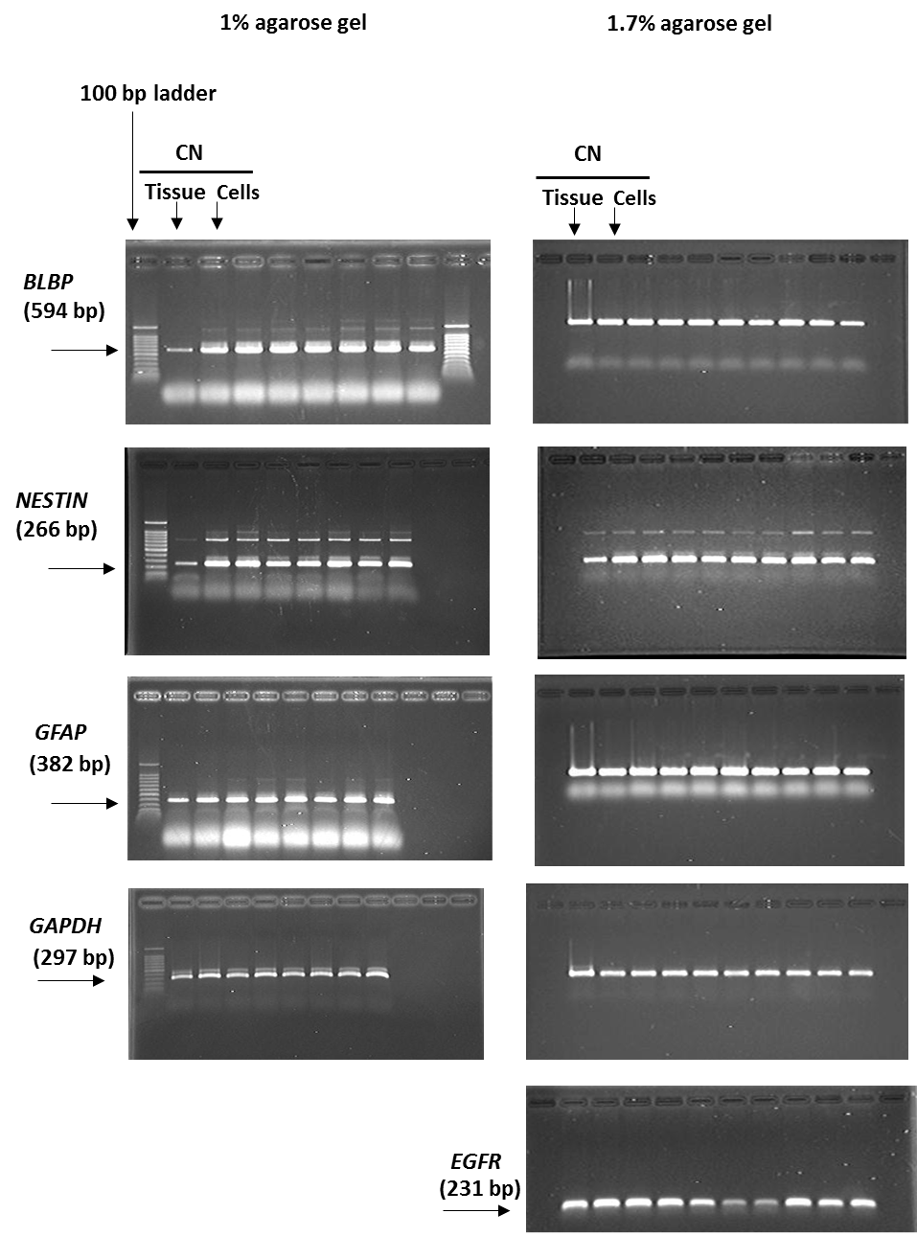

**Fig. 3b**

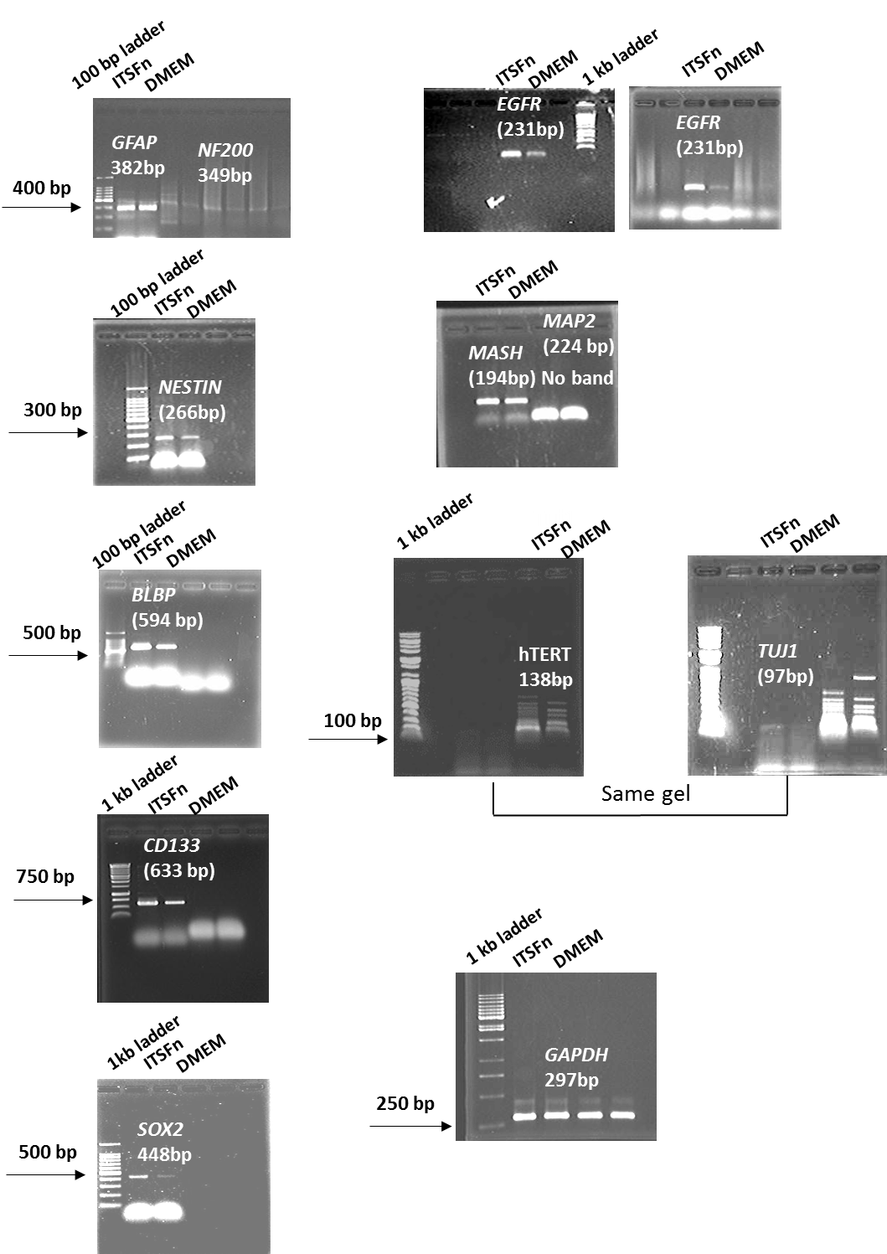

**Fig. 3t**

