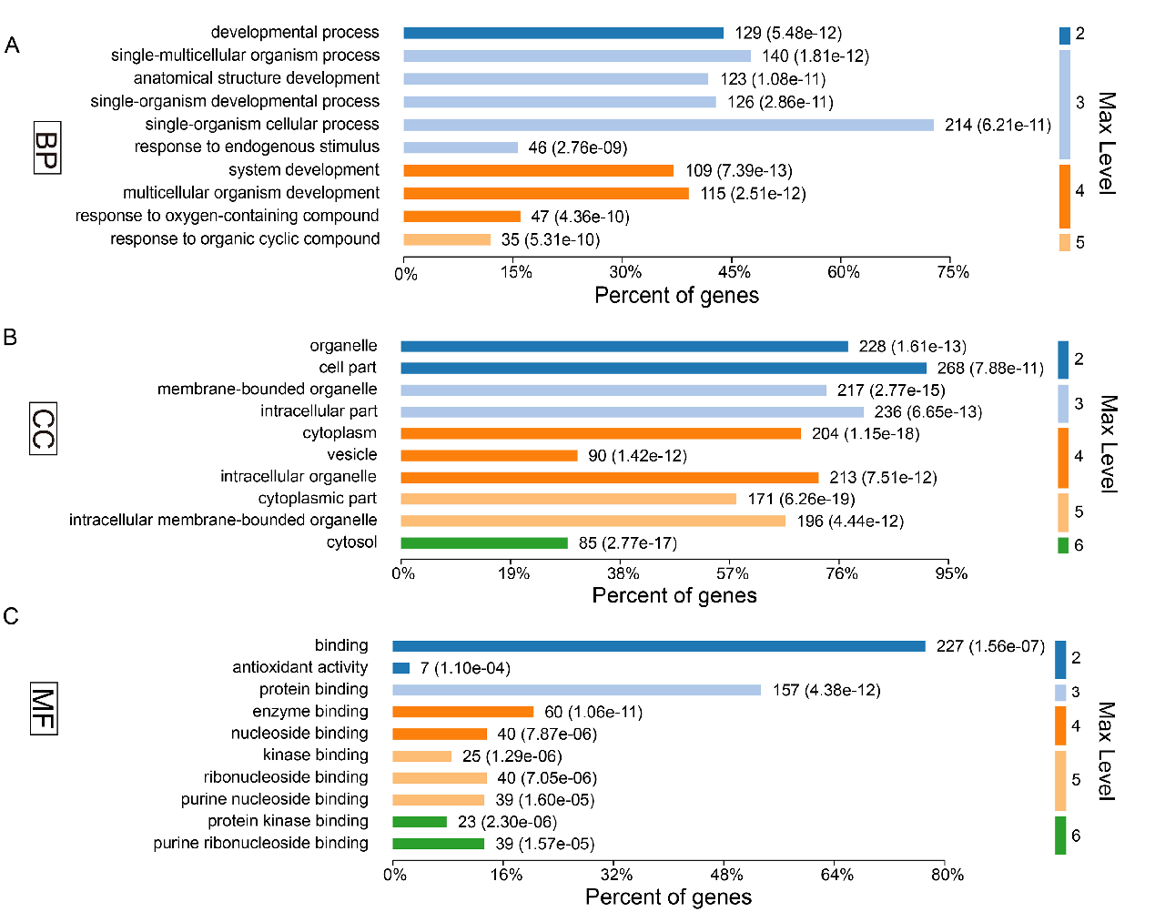
Figure S1. Gene ontology annotations of the total 303 differentially expressed proteins for (A) biological process, (B) cellular component and (C) molecular function.

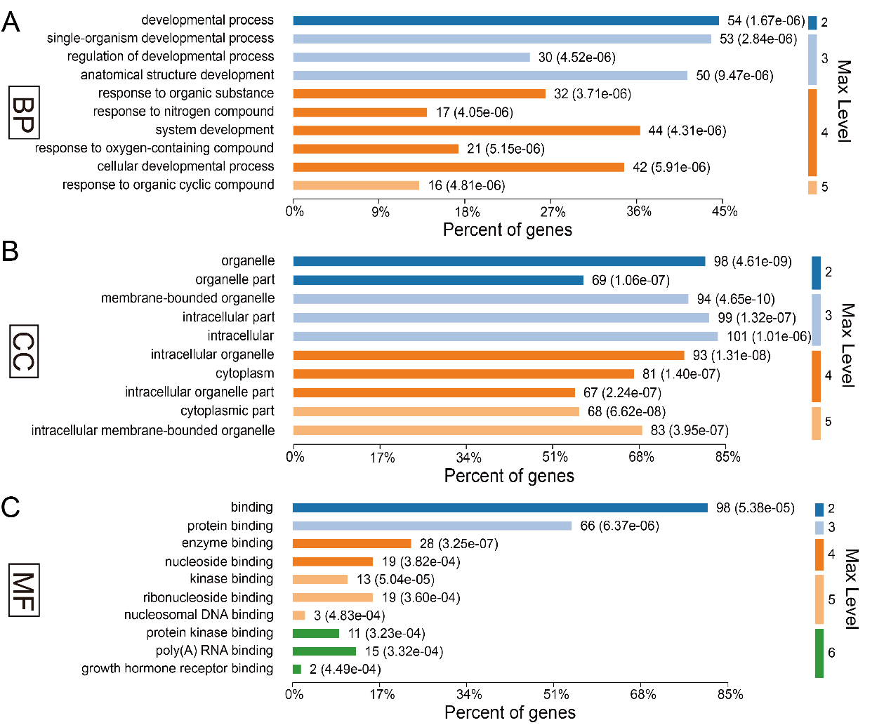
Figure S2. Gene ontology annotations of the 124 restored differentially expressed proteins for (A) biological process, (B) cellular component and (C) molecular function.

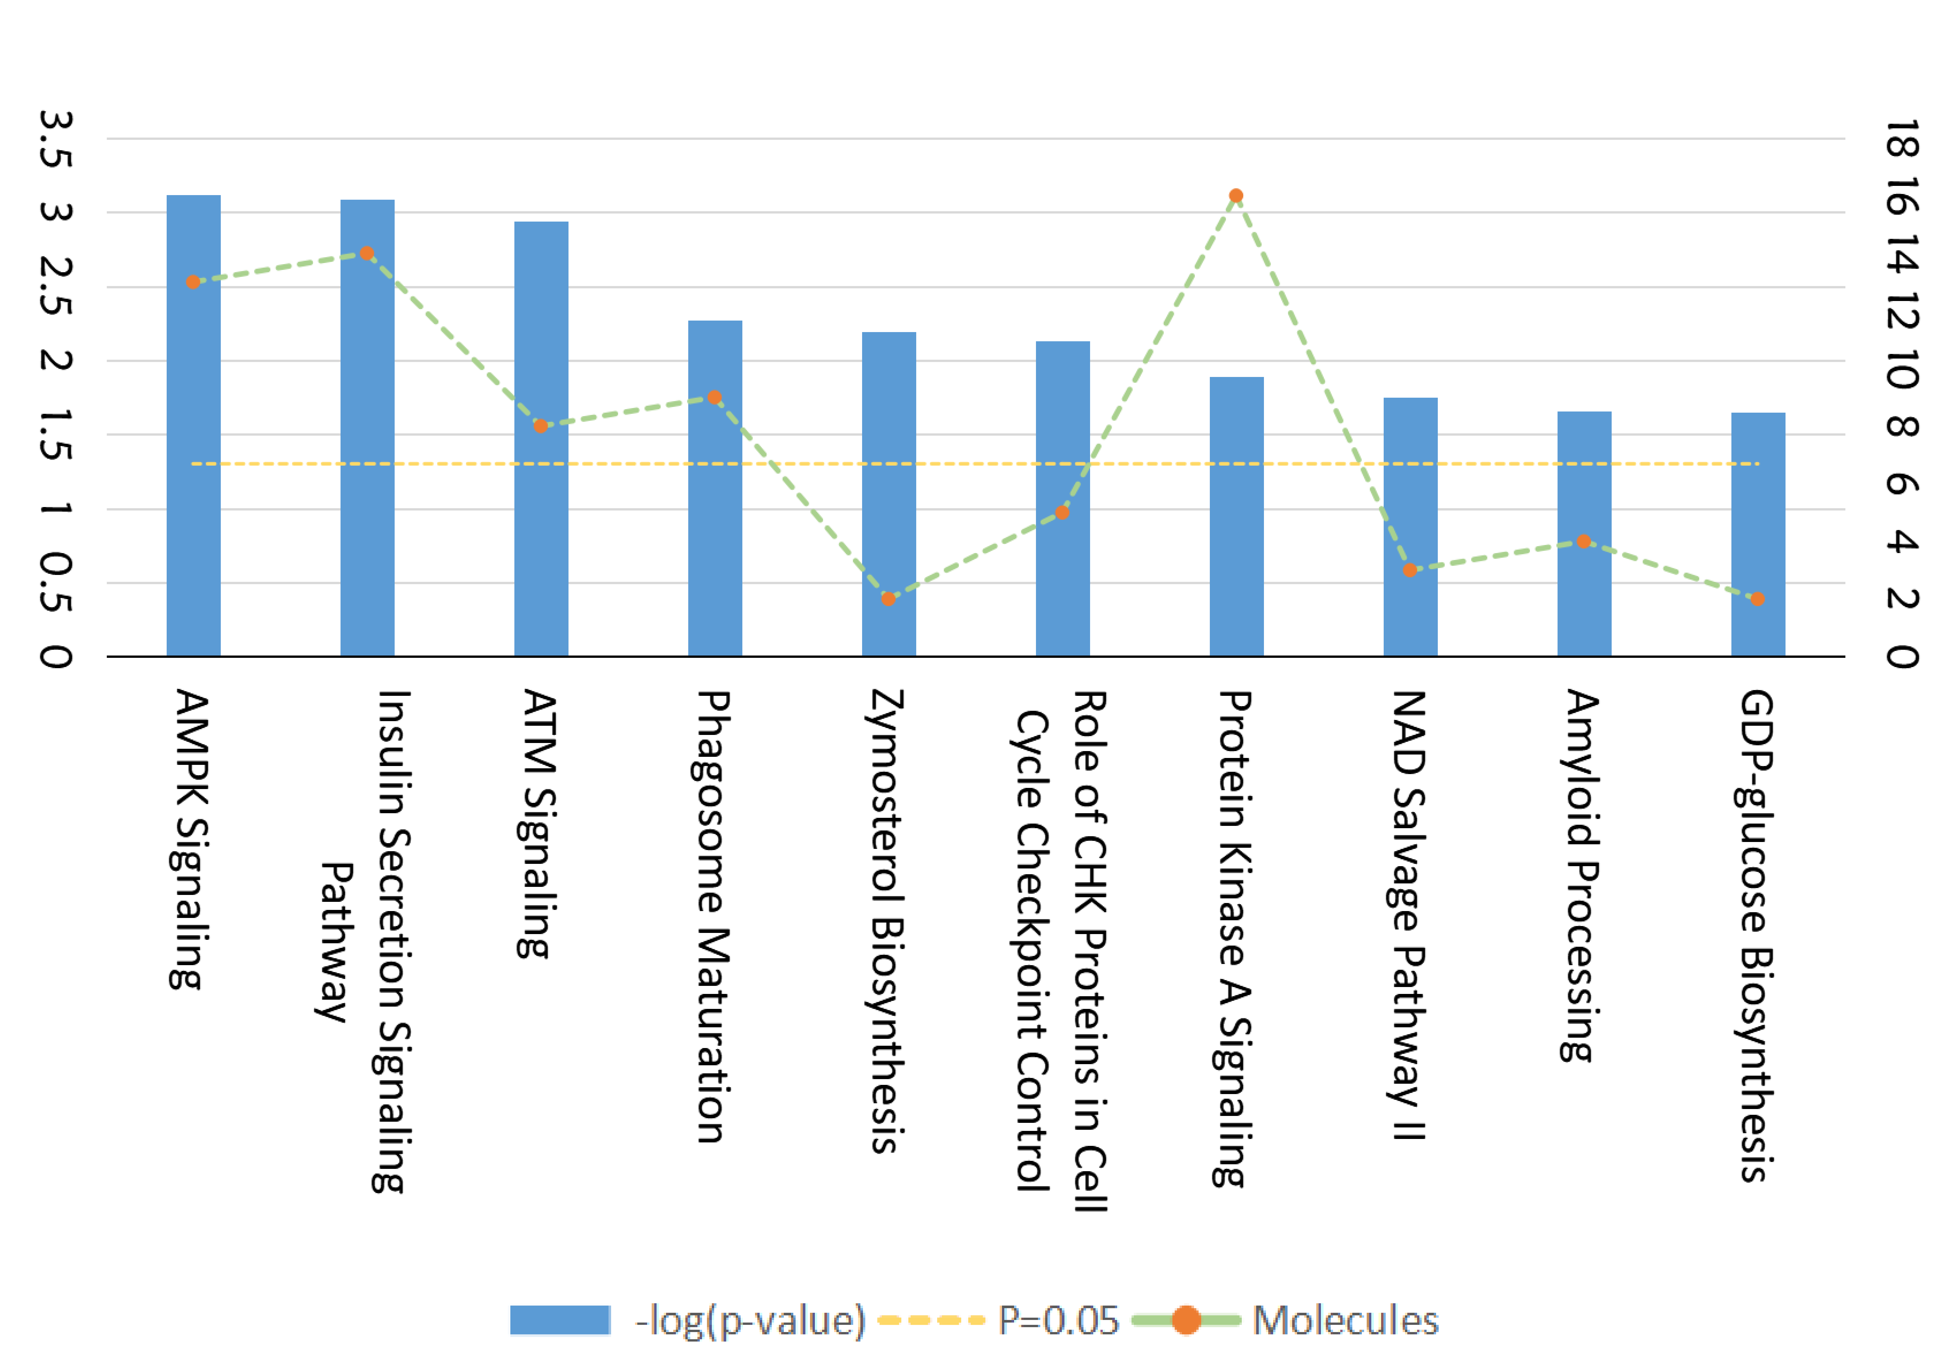
Figure S3. Ingenuity Pathway Analysis for GF vs. CGF comparison.

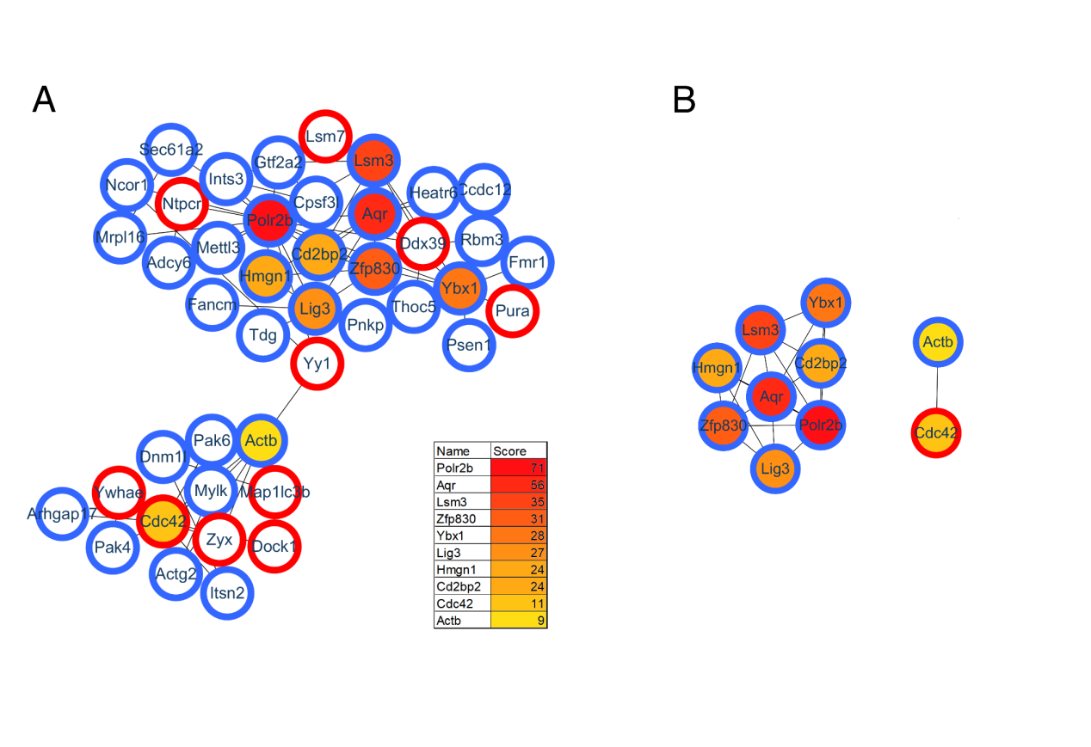
Figure S4. Protein-protein interaction analysis for GF vs. CGF comparison.

