Supplementary Information 1. Location of hdEEG and LFP electrodes and histological verifications.
- Montage of high density EEG electrodes. The cortical regions were colored according to the coordinates in the Mouse Brain in Stereotaxic Coordinates (Keith B.J. Franklin, George Paxinos, 3rd Ed, Academic Press). The numbers represent the electrode number of EEG electrode. FrA, frontal association cortex; M1, primary motor cortex; M2, secondary motor cortex; S1, primary somatosensory cortex; V1, primary visual cortex; V2, secondary visual cortex.
- Histological verification of the tip of reticular thalamic LFP electrode. RT, thalamic reticular nucleus; sm, stria medullaris of the thalamus; f, fornix, st, stria terminalis; IC, internal capsule.
- Histological verification of the tip of ventral basal LFP electrode. VB, ventrobasal nucleus.
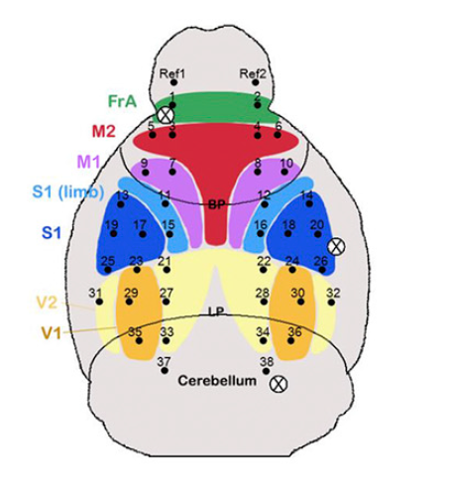
A

